Emergency Action Plan
ADDRESS: 1250 Cater Lee Way Foley, AL 36535
GPS Address: 999 W. Section Ave. Foley, AL 36535
Coordinates: _____________
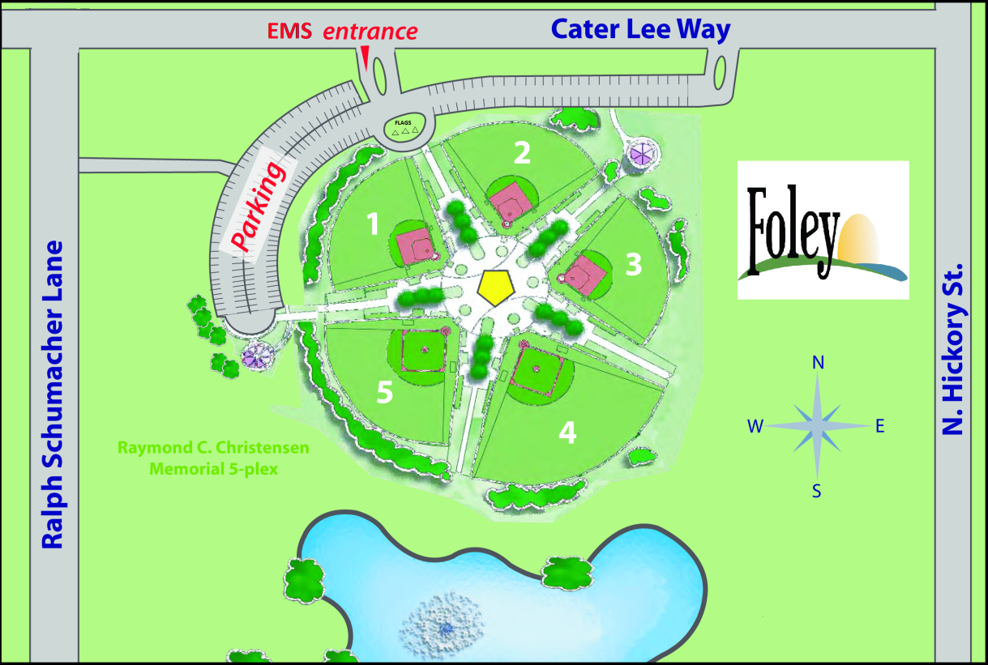

CONTACT NUMBERS:
Foley Police Dispatch: (251) 943-4431 of Emergency Ambulance/Fire: 911

INFO TO BE GIVEN TO 911 OPERATORS
Name and address of current location and phone number of caller
Type of emergency situation
Number of victims
Suspected injury/symptoms
Condition of Injured or ill
Current assistance being given
Other information as requested by the 911 operator. Be prepared to stay on the line.
EMERGENCY EQUIPMENT:
First Aid and AED located in the concession stand.
ABC Extinguisher and Class K Extinguisher are located within the concession stand.

CONSENT OR PARENT INFORMATION FORM:
Head Coach or person in charge (if guardian is not at available)
Head coach and witnesses should fill out the Incident Report

FSC STAFF RESPONSIBILITIES:
Control players and crowd (2 persons)
Meet EMS / Unlock doors and/or gates

COMMUNICATIONS:
Step 1: Contact 9-1-1 Immediately (Determined by the severity of the injury/illness.)
Step 2: First responder: Immediate attention should be given to the injured or ill outlined by the following:

If Heart Attack is suspected | If Stroke is suspected | If Neck or Back injury is suspected | If Concussion is suspected | If Broken Bone is suspected | If Heat Illness or Heat Stroke is suspected
Call EMS (9-1-1) immediately  If you suspect a heart attack. | Call EMS (9-1-1) immediately  If you suspect a stroke. | Call EMS (9-1-1)  Immediately if you suspect a neck or back injury. | Call EMS (9-1-1)  Immediately if you suspect a head injury. | Call EMS (9-1-1)  Immediately if you suspect a dislocation or fracture. | Call EMS (9-1-1)  Immediately if you suspect heat stroke or Heat Exhaustion.
Keep the person calm and loosen restrictive clothing. | Note: Time is critical in treating a stroke. | Do not move the victim unless he is in immediate danger of further injury or you need to open an airway for them to breathe | Assess the victim. Signs of head injury include drowsiness, severe headache or stiff neck, dizziness, speech difficulties or loss of consciousness. | Retrieve First Aid Splint in concession stand | Keep the person calm and loosen restrictive clothing.
Ask the person if he carries any prescribed medication for heart problems. | Assess for F.A.S.T. (can victim smile, raise both arms or repeat a simple phrase?). | Stabilize the victim to prevent any movement of the head, neck, or body. You want to keep the victim totally still until EMS arrives, if possible | Stop any bleeding by applying pressure with a clean cloth. | Apply ice packs to reduce swelling and alleviate pain until emergency personnel arrive. | Move the victim to a cool and shaded place.
Check the person’s breathing and pulse. Request the AED and begin CPR, if needed. | Check the person’s breathing and pulse. Request the AED and begin CPR, if needed. | If the victim is conscious, try to keep them calm. Explain what you are doing for them and ask that they remain still. | Immobilize the head and neck. | Splint the injury, if possible. Do Not Attempt to Force the Joint Back Into Place. | Allow the victims to drink cold fluids (heat exhaustion). Allow victim to rest  And monitor body temperature.
Turn patient care over to EMS personnel, upon their arrival. | Turn patient care over to EMS personnel, upon their arrival. | Check the person’s breathing and pulse. Request the AED and begin CPR, if needed.  Note: When opening the airway, use the modified jaw thrust and avoid the head tilt chin lift. | Check the person’s breathing and pulse. Request the AED and begin CPR, if needed. | Check the person’s breathing and pulse. Request the AED and begin CPR, if needed. | Check the person’s breathing and pulse. Request the AED and begin CPR, if needed.
Head coach and witnesses should fill out the Incident Report | Head coach and witnesses should fill out the Incident Report | Turn patient care over to EMS personnel, upon their arrival. | Turn patient care over to EMS personnel, upon their arrival. | Turn patient care over to EMS personnel, upon their arrival. | Turn patient care over to EMS personnel, upon their arrival.
 |  | Head coach and witnesses should fill out the Incident Report | Head coach and witnesses should fill out the Incident Report | Head coach and witnesses should fill out the Incident Report | Head coach and witnesses should fill out the Incident Report

Portable Fire Extinguishers
Types of Fire Extinguishers
 | Class A extinguishers put out fires in ordinary combustible materials such as cloth, wood, rubber, paper, and many plastics. | 
 | Class B extinguishers are used on fires involving flammable liquids, such as grease, gasoline, oil, and oil-based paints. | 
 | Class C extinguishers are suitable for use on fires involving appliances, tools, or other equipment that is electrically energized or plugged in. | 
 | Class D extinguishers are designed for use on flammable metals and are often specific for the type of metal in question. These are typically found only in factories working with these metals. | 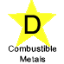
 | Class K fire extinguishers are intended for use on fires that involve vegetable oils, animal oils, or fats in cooking appliances. These extinguishers are generally found in commercial kitchens, such as those found in restaurants, cafeterias, and caterers. Class K extinguishers are now finding their way into the residential market for use in kitchens. | 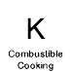

Is the fire at a point where it might be controlled by a fire extinguisher?
Portable fire extinguishers are valuable for immediate use on small fires. They contain a limited amount of extinguishing material and need to be properly used so that this material is not wasted. For example, when a pan initially catches fire, it may be safe to turn off the burner, place a lid on the pan, and use an extinguisher. By the time the fire has spread, however, these actions will not be adequate. Only trained firefighters can safely extinguish such fires.
Use a fire extinguisher only if:
- You have alerted other occupants and someone has called the fire department;
- The fire is small and contained to a single object, such as a wastebasket;
- You are safe from the toxic smoke produced by the fire;
- You have a means of escape identified and the fire is not between you and the escape route; and
- Your instincts tell you that it is safe to use an extinguisher.
If all of these conditions are not present, you should NOT try to use a fire extinguisher. Alert other occupants, leave the building following your escape plan, go to the agreed upon meeting place, and call the (9-1-1) from a cell phone.

How to Use a Portable Fire Extinguisher
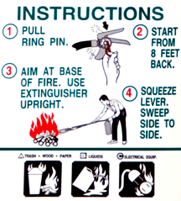

Note: Make sure to utilize the correct fire extinguisher for the fire type. The concession stand is equipped with ABC multi-use extinguishers and Class K extinguishers (Grease). The definitions for each class of fire are listed above.

